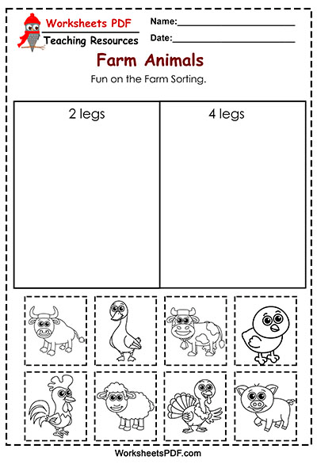
Źródło: https://worksheetspdf.com/farm-animals/fun-on-the-farm-sorting

